**Payments Module**

Work flow

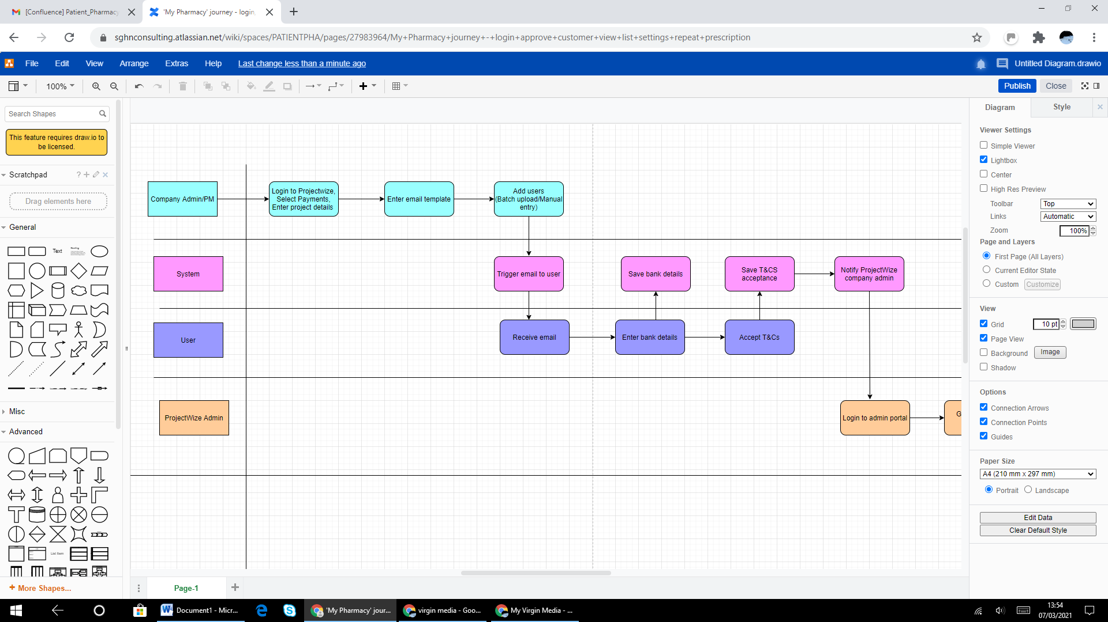

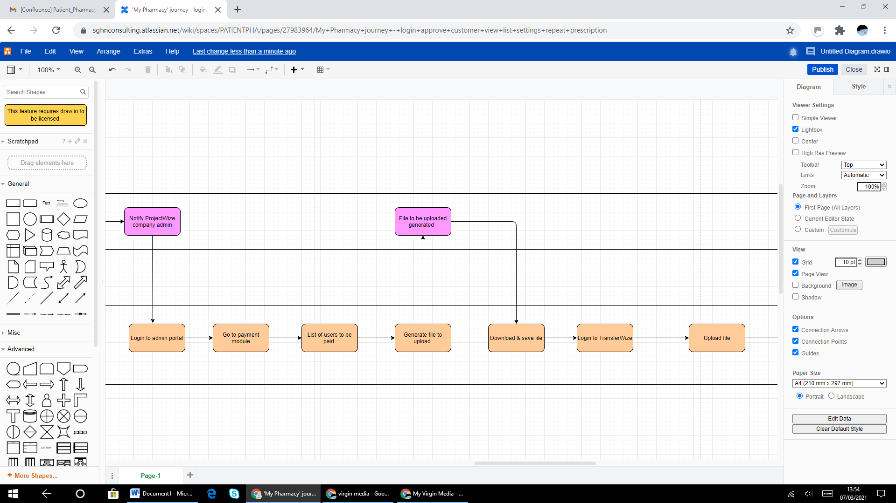

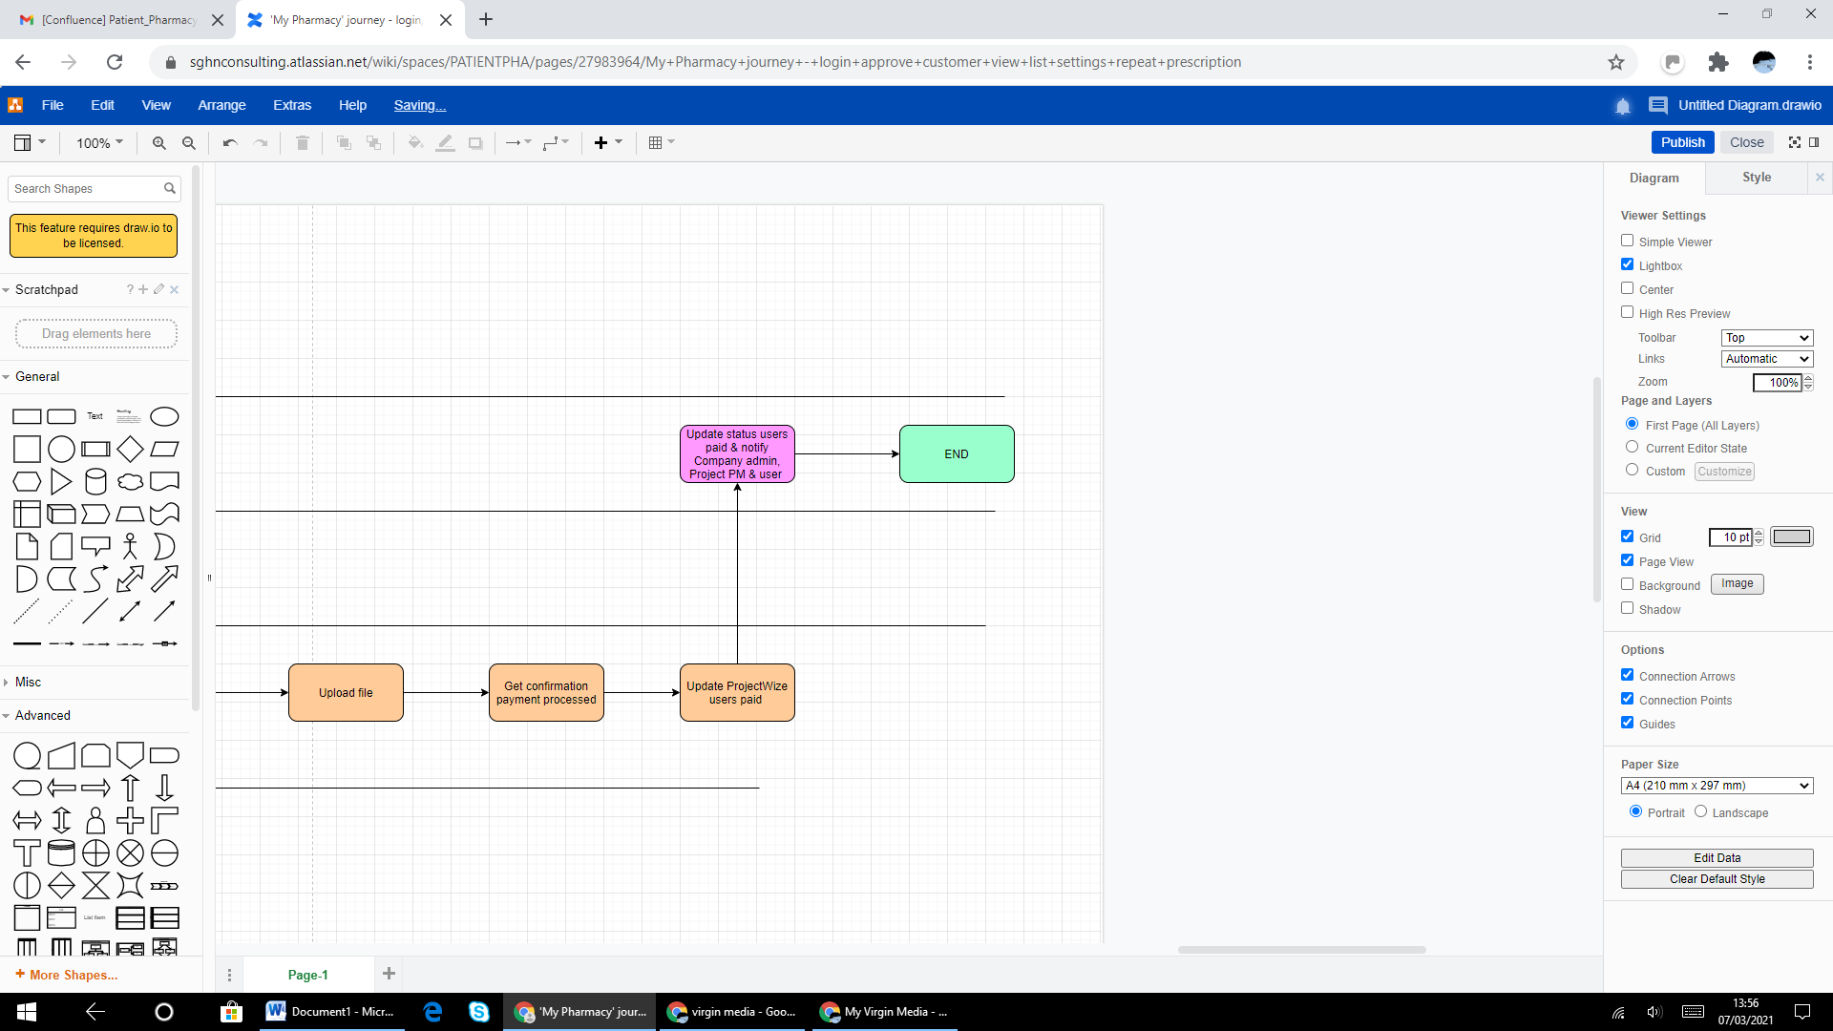

**Add New Project Manager**

|  |  |  |  |
| --- | --- | --- | --- |
| **Field Name** | **Field Type/Description** | **Validation** | **Comments** |
| Add New Project Manager | Label | NA | NA |
| First Name* | Text Box | Mandatory  Alphanumeric can include special characters  Min 2 characters  Max 50 characters |  |
| Last Name* | Text Box | Mandatory  Alphanumeric can include special characters  Min 2 characters  Max 50 characters |  |
| Email id* | Text Box | Mandatory  Alphanumeric,  maximum of 64 characters in the "local part" (before the "@") and a maximum of 255 characters in the domain part (after the "@") for a total length of 320 characters  Must have @ and .com |  |
| Contact Number* | Text field | Mandatory  Numeric only  Default value 0  Must be 11 digits with the zero  Must be 10 digits without zero |  |
| Add | Button | Checks for all validation & Saves the details entered |  |
| Close | Button | Closes the window and brings the user back to previous screen that triggered the pop-window |  |

**Add Project Details**

|  |  |  |  |
| --- | --- | --- | --- |
| **Field Name** | **Field Type/Description** | **Validation** | **Comments** |
| Project Details | Label. Page Heading |  |  |
| Project Title* | Text Box | Mandatory, Alpha Numeric , Min = 3 letters, Max = 50 characters |  |
| Payment Reference* | Text Box | Mandatory, Alpha Numeric , Could be combination of letters and numbers, Min = 3 characters, Max = 18 characters  No special characters allowed. |  |
| Project Description | Text Box | Not - Mandatory, Alpha Numeric , Max = 500 characters |  |
| Project Manager* | Drop down | Mandatory, List of all Project managers added to the company | If no Project Manager is available then display a link Add Project Manager. To be checked with Hemal what is less work. |
| Add Project Manager | Link | Opens a pop-up and takes user to Add project Manager screen | After the user has added a PM and closed the pop-window bring back the user to this screen |
| Project Manager Contact Number | Label | Displayed from PM screen |  |
| Project Manager Email | Label | Displayed from PM screen |  |
| Incentive | Text Box | Not - Mandatory, numeric, min = 3 Max 5 |  |
| Number of participants | Text Box | Not Mandatory, numeric, min = 2 Max 3-5 |  |
| Number of groups | Text Box | Not Mandatory, numeric, min = 1 Max 3 |  |
| Project Start Date | Calendar | Must have a date picker/calendar  Should be |  |
| Project Specific Terms & Conditions * | Radio button  Options Yes & No | Mandatory |  |
| This question is asked to check if the client wants the respondent to sign or accept any project specific terms and conditions. These will be sent to the respondent either as part of the welcome email or during taking payment details. | Label |  |  |
| Does the user need to sign the terms and conditions Or Can only tick a Check Box | Radio button  Options  User should Sign T&Cs  User can only tick a Check Box | Mandatory if Project Specific Terms & Conditions is YES |  |
| Upload T&Cs | Button | Mandatory if Project Specific Terms & Conditions is YES  User should be able to browse and upload a file  If user need to sign the terms  then Accepted format = .doc only  If user can only tick a Check Box  then Accepted format = .doc, pdf,textfile  Max size 500 MB  (to be checked with Hemal) |  |
| Preview Email Template |  |  |  |
| Standard | Link | Opens a pop-up window with standard email template |  |
| Customise | Link | Opens a pop-up window with customise email template. The user would be able to change the text of the template |  |
| Add | Button | Checks for all validation & Saves the details entered |  |
| Close | Button | Closes the window and brings the user back to previous screen that triggered the pop-window |  |

**Standard Email Template**

**Enter User details**

|  |  |  |  |
| --- | --- | --- | --- |
| **Field Name** | **Field Type/Description** | **Validation** | **Comments** |
| User Details | Label | NA | NA |
| Salutation* | Drop down  Options:  Select  Mr,  Mrs,  Miss,  Dr.  Prefer not to say | Mandatory, Default value Select |  |
| First Name* | Text Box | Mandatory  Alphanumeric can include special characters  Min 2 characters  Max 50 characters |  |
| Last name* | Text Box | Mandatory  Alphanumeric can include special characters  Min 2 characters  Max 50 characters |  |
| Email id* | Text Box | Mandatory  Alphanumeric,  maximum of 64 characters in the "local part" (before the "@") and a maximum of 255 characters in the domain part (after the "@") for a total length of 320 characters  Must have @ and .com |  |
| Mobile number* | Text field | Mandatory  Numeric only  Default value 0  Must be 11 digits with the zero  Must be 10 digits without zero |  |
| Project Title* | Drop down  All the active projects for the company | Mandatory  If no value available in the project then display a link to Project Details |  |
| Add Project | Link | Must open the Add Project Details screen in a pop-up window |  |
| Project Reference | Label | Displayed based on the project selected |  |
| Incentive* | Text Box | Mandatory, numeric, min = 3 Max 5  Default value – Incentive as entered for the project in the project details screen  Blank if not entered in the project details screen |  |
| Add | Button | Checks for all validation & Saves the details entered |  |
| Close | Button | Closes the window and brings the user back to previous screen that triggered the pop-window |  |

**Payments Module**

Company admin will see the following options in Payment modules.

* Add Users
* Pending Bank Details
* Pending T&Cs Signature
* Pending Payments
* Paid

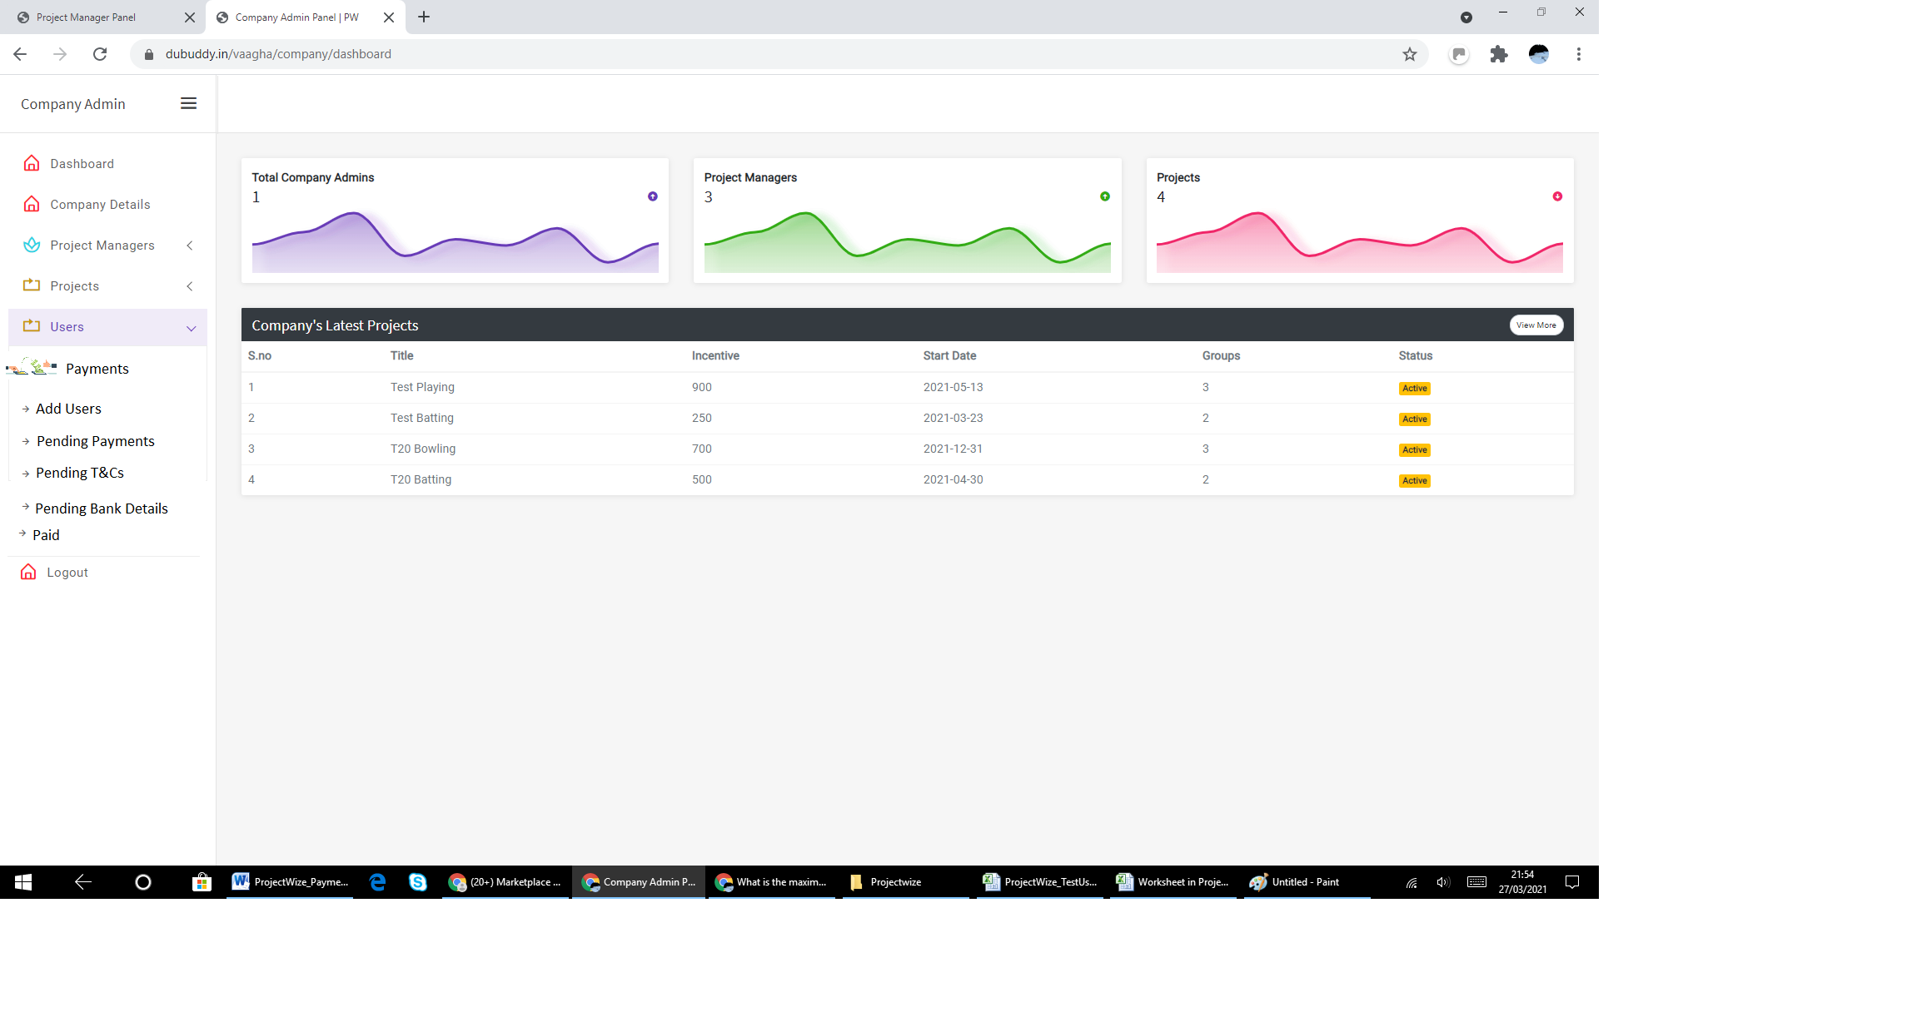

**Add Users for Payments**

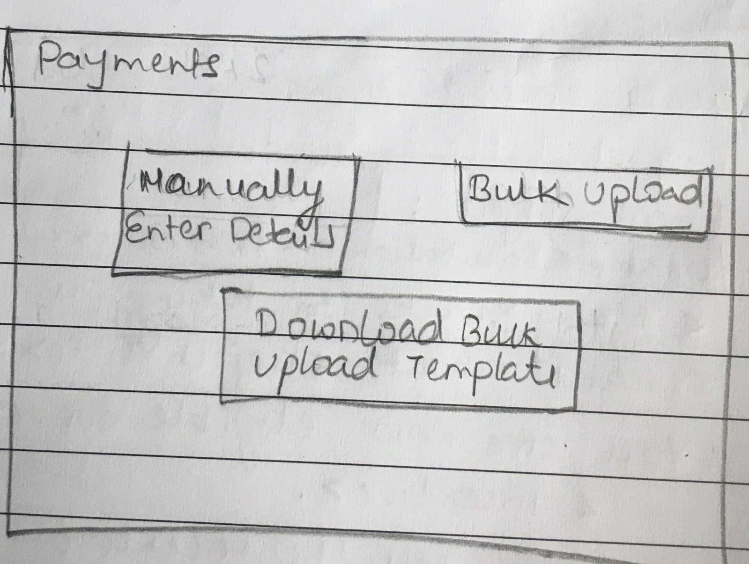

User will have the option to enter details manually or bulk upload.

|  |  |  |  |
| --- | --- | --- | --- |
| **Field Name** | **Field Type/Description** | **Validation** | **Comments** |
| Add Users for Payments | Label/Screen Title | NA | NA |
| Manually add users | Link | When user clicks on this the user will be displayed Project Details |  |
| Bulk upload users | Link | When user clicks on this the user will be able to upload users  Validate formats – CSV, excel | For Bulk upload, user will have to download the bulk upload template and fill it and upload via bulk upload functionality. |
| Download bulk upload template | Link | When user clicks on this the user will be able to download the file |  |

**Select & send email to end user to provide bank details**

Once user uploads the user details via bulk upload functionality, the company admin will be displayed the following screen.

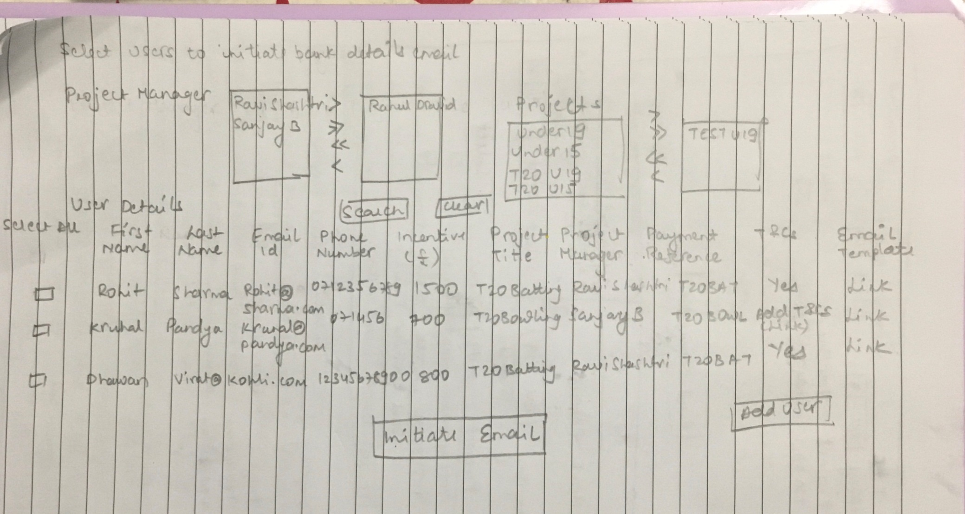

In this screen the user will be able to

* Upload T&Cs
* Select individual users to send an email to enter bank details
* Select multiple users to send an email to enter bank details
* Select all users to send an email to enter bank details
* Add individual users manually.

The Initiate email button should not be clickable if there is no email template selected

The Initiate email button should not be clickable if T&Cs is Yes and no T&C is uploaded

|  |  |  |  |
| --- | --- | --- | --- |
| **Field Name** | **Field Type/Description** | **Validation** | **Comments** |
| Users to Capture Bank Details | Label | NA | NA |
|  |  |  |  |
| Project Manager | Multiple selectable field | Display all the project managers that are mapped to the company.  By Default – All | It should be possible to select one project manager or all and  deselect one project manager or all |
| Project Title | Drop Down | Display all the projects that are mapped to the selected project managers.  By Default – All | It should be possible to select one project manager or all and  deselect one project manager or all |
| Search | Button | Display users for the selected projects or selected project managers that are mapped to the company.  By Default – All |  |
| Clear | Button | Clears all selection. No project manager or project selected. |  |
| Add Users | Button | Should open the Enter User details pop-up |  |
| User Details | Title of the table |  |  |
| Select All | Link | By default not selected.  When clicked , all users/check boxes against all users must be selected |  |
|  | Check Box | By default not selected.  When selected and clicked on Initiate email button must send email to the selected user | From here the details must be repeated |
| First Name | Label | Display the First Name of the user from the uploaded file or manually added user |  |
| Last Name | Label | Display the Last Name of the user from the uploaded file or manually added user |  |
| Email Id | Label | Display the Email id of the user from the uploaded file or manually added user |  |
| Phone Number | Label | Display the Phone number of the user from the uploaded file or manually added user |  |
| Incentive | Label | Display the Incentive of the user from the uploaded file or manually added user |  |
| Project Title | Label | Display the Project Title of the user from the uploaded file or manually added user |  |
| Project Manager | Label | Display the Project Title of the user from the uploaded file or manually added user |  |
| Payment Reference | Label | Display the Payment Reference of the user from the uploaded file or manually added user |  |
| T&Cs | Label | Display the Option Yes/No from the uploaded file or manually added project details |  |
| Email template | Link | Display the email in pop-up |  |
| Initiate Email | Button | Will initiate email to the selected user/s and change the status of the user to Email sent | This will be only button common for all users |

**Email to end user to provide bank details**

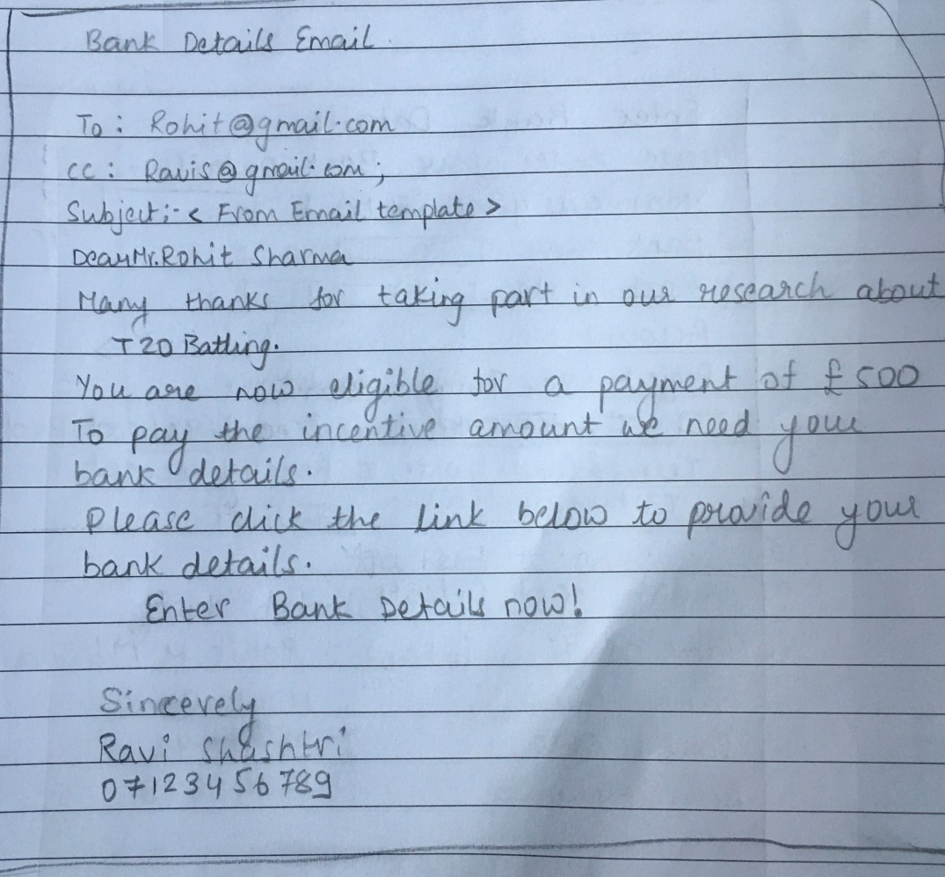

The email will have a link to enter bank details. When end user clicks on the screen , the user will be taken to the Authentication Screen.

|  |  |  |  |
| --- | --- | --- | --- |
| **Field Name** | **Field Type/Description** | **Validation** | **Comments** |
| Email text | Label | Text must be as per the email template |  |
| Enter Bank Details Now | Link | Should take the user to Authentication screen | This link should be unique to the user |

**Authentication Screen**

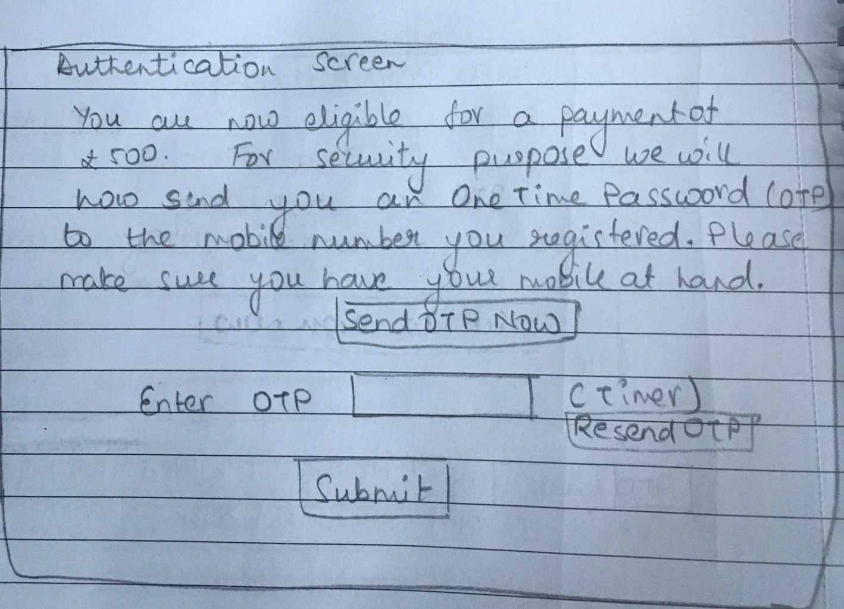

On this screen the user will be able to request OTP. When the user clicks on Send OTP now button, an 4-digit unique OTP should be generated & sent to the user’s registered mobile number.

The user should be prompted to enter the OTP . The user should also have the option to Resend OTP. When the user enters the correct OTP and clicks on Submit, the OTP must be validated and if correct, user must be displayed the bank details capture screen.

|  |  |  |  |
| --- | --- | --- | --- |
| **Field Name** | **Field Type/Description** | **Validation** | **Comments** |
| Authentication | Label | NA |  |
| Text  You are now eligible for a payment of £<incentive of the user>. For security purpose we will now send you an One-time-password (OTP) to the mobile number <078xxxxxx12> you have registered. Please make sure you have the mobile at hand. | Label | Display first 2 digits and last two digits of the mobile number. All other digits must be masked with *  Mobile number is the users mobile number |  |
| Send OTP now | Button | When clicked generates a 6-digit OTP and sends it as an SMS to the users mobile number | The OTP must be valid for 5 minutes. This time must be configurable. |
| Enter OTP | Text Field | Mandatory  Numeric only |  |
| Resend OTP | Button | When clicked generates a 6-digit OTP and sends it as an SMS to the users mobile number |  |
| Submit | Button | On click checks if the OTP entered is correct. If correct then display the Enter Bank details screen.  If incorrect, display a pop-up message, OTP incorrect please try again. | The user should be able to try / enter incorrect OTP for 5 times. After the 5th incorrect attempt, block the user account. |

**Enter Bank Details**

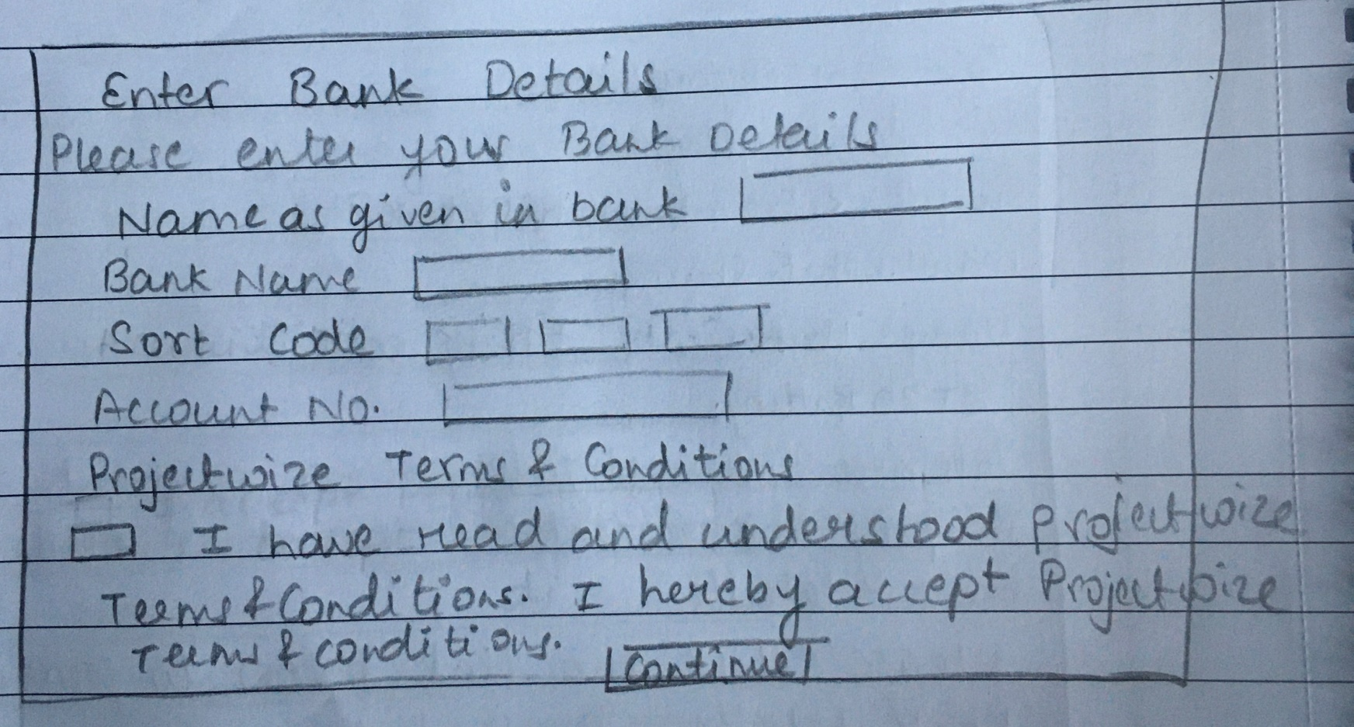

On this screen, the user should have the ability to enter bank details. The continue button must be disabled until the user ticks the check box and accepts Projectwize T&Cs.

|  |  |  |  |
| --- | --- | --- | --- |
| **Field Name** | **Field Type/Description** | **Validation** | **Comments** |
| Full Name as given in bank | Text field | Mandatory, Alphanumeric, Min 3 characters maximum 225 characters |  |
| Bank Name | Text field | Mandatory, Alphanumeric, Min 3 characters maximum 225 characters |  |
| Sort Code | Text field | Mandatory  Numeric Must be 6-digits |  |
| Account | Text field | Mandatory  Numeric Must be 8-digits |  |
| ProjectWize T&C | Check Box | Mandatory |  |
| ProjectWize T&C | Label |  | This is the Text as given in the screen shot |
| Client T&C | Check Box | This field is displayed only when admin / project manager has selected “User can only tick a Check Box” in the field Does the user need to sign the terms and conditions Or Can only tick a Check Box |  |
| Client T&C | Label |  | This is the Text as given in the screen shot |
| Continue | Button | By default disabled.  The Continue button is only enabled when the user selects both the check boxes |  |

**Confirm Bank Details**

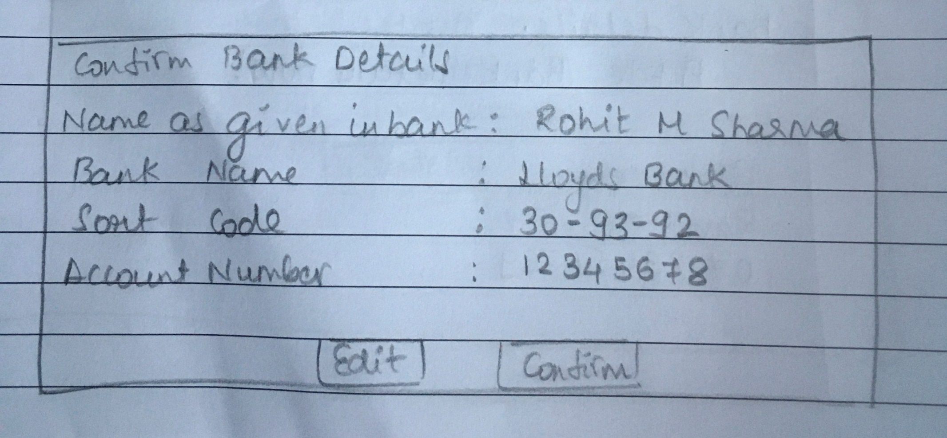

On this screen, the user should be able to check the bank details provided and either edit (in which case user is taken back to the Enter Bank details screen) or Confirms the details. If the user confirms the bank details, then user is shown the success screen.

|  |  |  |  |
| --- | --- | --- | --- |
| **Field Name** | **Field Type/Description** | **Validation** | **Comments** |
| Confirm bank details | Screen title |  |  |
| Full Name as given in bank | Label | As given by the user in the previous screen |  |
| Bank Name | Label | As given by the user in the previous screen |  |
| Sort Code | Label | As given by the user in the previous screen |  |
| Account | Label | As given by the user in the previous screen |  |
| Edit | Button | Takes the user back to the enter bank details screen |  |
| Confirm | Button | Will save the details against the user. and change the status of the user to Bank Details provided  If the user has accepted the client T&Cs, then change status to Accepted T&Cs change the status of the user to T&Cs accepted  Once the user bank details are saved, then the Link in the email must expire. The user should not be able to enter bank details again. | If the user clicks on the link again, then check the user should be taken to the appropriate screen depending on the status |

**Success screen**

On this screen, the end user is told that the bank details were captured successfully.

If the company needs the user to Sign their T&Cs, then the user is prompted to sign the T&Cs by clicking the button/link Sign Now

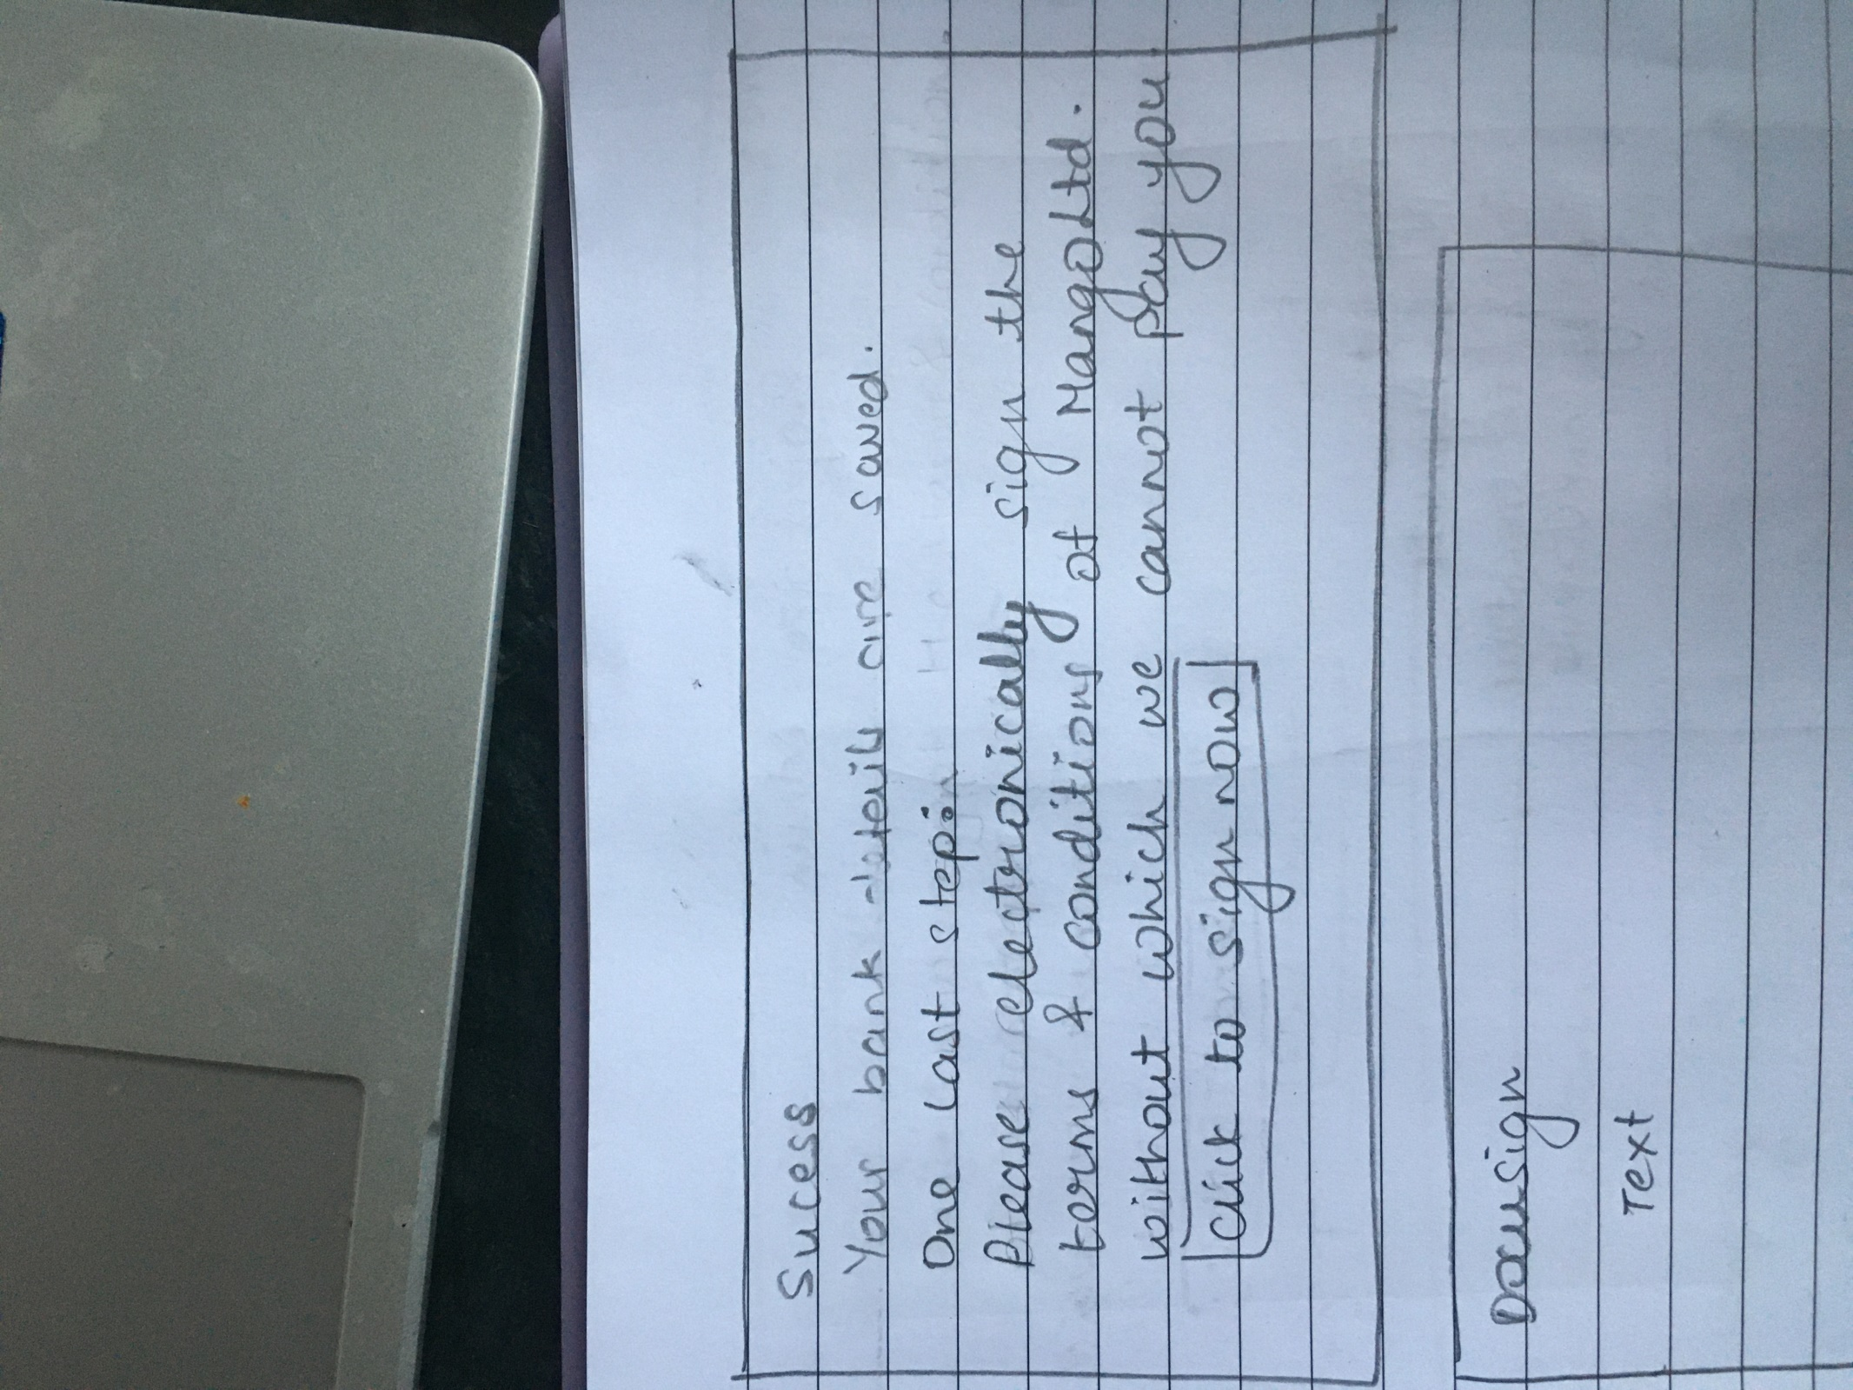

When user clicks on the Sign Now button/link, the user is taken to the DocuSign page to sign the documents.

|  |  |  |  |
| --- | --- | --- | --- |
| **Field Name** | **Field Type/Description** | **Validation** | **Comments** |
| Success | Screen Title |  |  |
| <Your bank details are saved> | Label |  |  |
| <Please digitally sign the terms and conditions of <project title> without which we cannot pay you. | Label | This text is displayed only if the answer to the question “Does the user need to sign the terms and conditions “ in Project Details is “User should Sign T&Cs” | Project Title from Project details. |
| Click to sign now | Link | Displayed only if the answer to the question “Does the user need to sign the terms and conditions “ in Project Details is “User should Sign T&Cs”.  Takes the user to the docusign page to sign the T&Cs |  |

**DocuSign Screen**

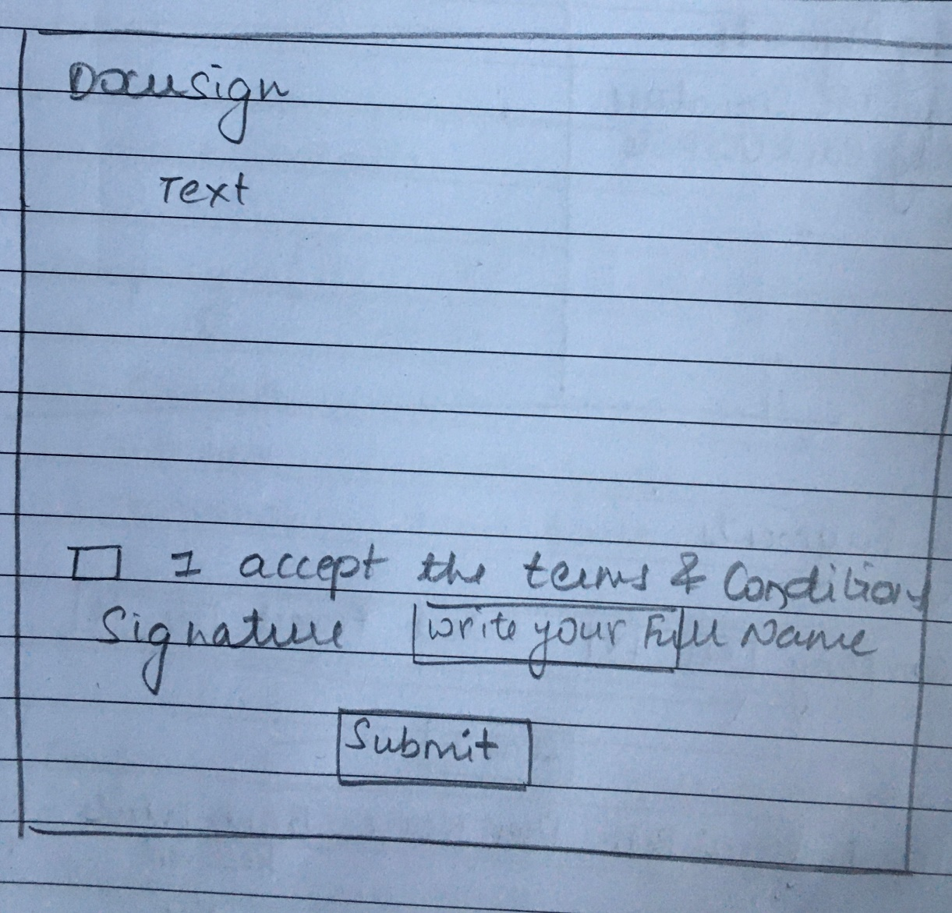

On this screen the user signs the document electronically. This is noted by changing the user’s payment status.

|  |  |  |  |
| --- | --- | --- | --- |
| **Field Name** | **Field Type/Description** | **Validation** | **Comments** |
| Submit | Button | Enabled only when user has signed the T&Cs  When user clicks on the button then save the T&Cs and change the payment status of the user to “T&Cs signed, pending payment”. |  |

**User’s payment statuses**

|  |  |  |
| --- | --- | --- |
| Status | Description | If user clicks on the link |
| Research completed, pending email | This is the first payment status when the user is created in payments module or bulk uploaded. | NA |
| Email failed | When the email has not reached the user | NA |
| Email sent, Pending Bank details | User has received email but not yet completed bank details | Display Authentication Screen |
| Bank details received, NO T&Cs required, pending payment | User has entered bank details and does not has not accept the T&Cs, pending payment | Display message “You have provided the bank details. If there is a problem contact your project manager”. |
| Bank details received, pending T&Cs signature | User has entered bank details but has not accepted the T&Cs | Display the Success screen |
| T&Cs signed, pending payment | User has accepted T&Cs , pending payment | Display message “You have provided the bank details. If there is a problem, contact your project manager”. |
| Payment initiated | Projectwize admin has downloaded the user details to be uploaded to Transferwize | Display message “You have provided the bank details. If there is a problem, contact your project manager”. |
| Paid, status updated in Projectwize & email sent to PM, company admin and user | Confirmation has received that the user has been paid and the Projectwize admin has updated the status in Projectwize | Display message “You have been paid. If there is a problem, contact your project manager”. |

**Automatic reminder email**

|  |  |  |
| --- | --- | --- |
| Status | Reminder email | Email Template |
| Research completed, pending email | NA | NA |
| Email failed | NA | NA |
| Email sent, Pending Bank details | Send a 1st reminder email after 7 days if user has not provided bank details. 7 must be a configurable number | 1st email reminder template – Bank details not provided |
| 1st reminder email sent, Pending Bank details | Send 2nd reminder email after 3 days if user has not provided bank details. A copy must be sent to the PM. 3 must be a configurable number | 2nd email reminder template – Bank details not provided |
| Bank details received, NO T&Cs required, pending payment | NA | NA |
| Bank details received, pending T&Cs signature | Send a 1st reminder email after 7 days if user has not provided bank details. 7 must be a configurable number | 1st email reminder template – T&Cs pending |
| Bank details received, pending T&Cs signature | Send 2nd reminder email after 3 days if user has not provided bank details. A copy must be sent to the PM. 3 must be a configurable number | 2nd email reminder template – T&Cs pending |

**Pending Bank Details**

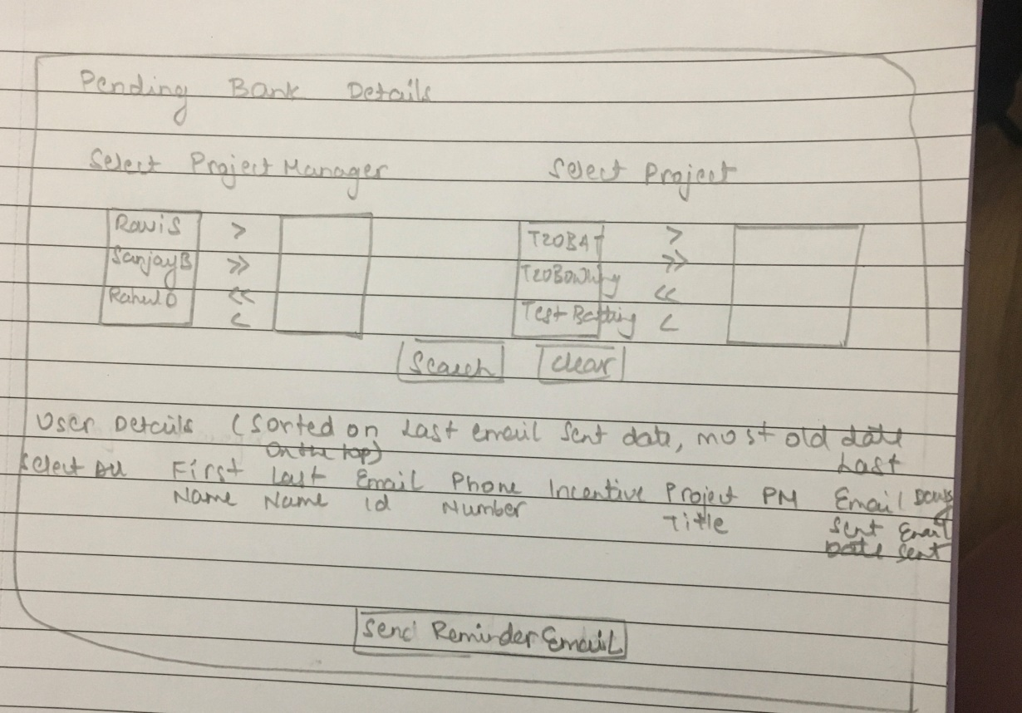

|  |  |  |  |
| --- | --- | --- | --- |
| **Field Name** | **Field Type/Description** | **Validation** | **Comments** |
| Users Pending Bank Details | Screen Title | NA | NA |
| Company | Multiple selectable field | Display all the companies  By Default – All  It should be possible to select one project manager or all and  deselect one project manager or all | This field is displayed only to the ProejctWize admin |
| Project Manager | Multiple selectable field | Display all the project managers that are mapped to the company.  By Default – All | It should be possible to select one project manager or all and  deselect one project manager or all |
| Project Title | Multiple selectable field | Display all the projects that are mapped to the selected project managers.  By Default – All | It should be possible to select one project manager or all and  deselect one project manager or all |
| Search | Button | Display users for the selected projects or selected project managers that are mapped to the company.  By Default – All |  |
| Clear | Button | Clears all selection. No project manager or project selected. |  |
| User Details | Title of the table |  | The users must be sorted on the last email sent date with the oldest record (date) first/top of the list |
| Select All | Link | By default not selected.  When clicked , all users/check boxes against all users must be selected |  |
|  | Check Box | By default not selected.  When selected and clicked on Initiate email button must send email to the selected user | From here the details must be repeated |
| First Name | Label | Display the First Name of the user from the uploaded file or manually added user |  |
| Last Name | Label | Display the Last Name of the user from the uploaded file or manually added user |  |
| Email Id | Label | Display the Email id of the user from the uploaded file or manually added user |  |
| Phone Number | Label | Display the Phone number of the user from the uploaded file or manually added user |  |
| Incentive | Label | Display the Incentive of the user from the uploaded file or manually added user |  |
| Project Title | Label | Display the Project Title of the user from the uploaded file or manually added user |  |
| Project Manager | Label | Display the Project Title of the user from the uploaded file or manually added user |  |
| Last email sent date | Label | The date on which the last email was sent |  |
| Days lapsed since last email | Label | Days passed since the last email was sent (Last email sent date – Today’s date) |  |
|  |  |  |  |
| Send Reminder Email | Button | Will initiate email to the selected user/s | This will be a common button for all users |

**Pending T&Cs signature**

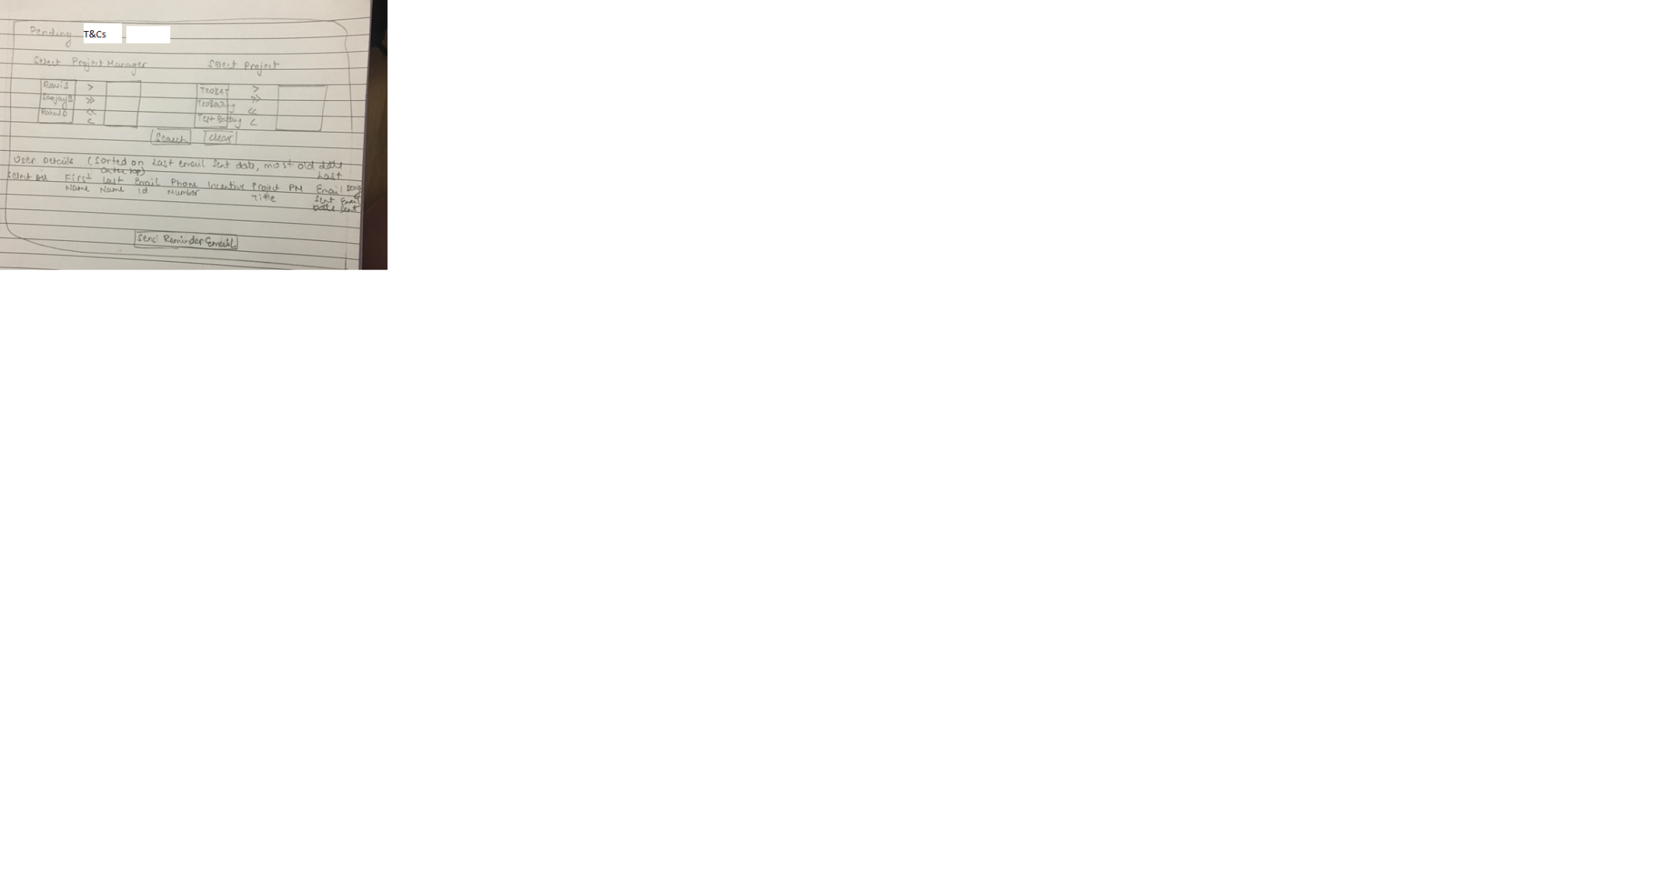

|  |  |  |  |
| --- | --- | --- | --- |
| **Field Name** | **Field Type/Description** | **Validation** | **Comments** |
| Users Pending Bank Details | Screen Title | NA | NA |
| Company | Multiple selectable field | Display all the companies  By Default – All  It should be possible to select one project manager or all and  deselect one project manager or all | This field is displayed only to the ProejctWize admin |
| Project Manager | Multiple selectable field | Display all the project managers that are mapped to the company.  By Default – All | It should be possible to select one project manager or all and  deselect one project manager or all |
| Project Title | Multiple selectable field | Display all the projects that are mapped to the selected project managers.  By Default – All | It should be possible to select one project manager or all and  deselect one project manager or all |
| Search | Button | Display users for the selected projects or selected project managers that are mapped to the company.  By Default – All |  |
| Clear | Button | Clears all selection. No project manager or project selected. |  |
| User Details | Title of the table |  | The users must be sorted on the last email sent date with the oldest record (date) first/top of the list |
| Select All | Link | By default not selected.  When clicked , all users/check boxes against all users must be selected |  |
|  | Check Box | By default not selected.  When selected and clicked on Initiate email button must send email to the selected user | From here the details must be repeated |
| First Name | Label | Display the First Name of the user from the uploaded file or manually added user |  |
| Last Name | Label | Display the Last Name of the user from the uploaded file or manually added user |  |
| Email Id | Label | Display the Email id of the user from the uploaded file or manually added user |  |
| Phone Number | Label | Display the Phone number of the user from the uploaded file or manually added user |  |
| Incentive | Label | Display the Incentive of the user from the uploaded file or manually added user |  |
| Project Title | Label | Display the Project Title of the user from the uploaded file or manually added user |  |
| Project Manager | Label | Display the Project Title of the user from the uploaded file or manually added user |  |
| Last email sent date | Label | The date on which the last email was sent |  |
| Days lapsed since last email | Label | Days passed since the last email was sent (Last email sent date – Today’s date) |  |
|  |  |  |  |
| Send Reminder Email | Button | Will initiate email to the selected user/s | This will be a common button for all users |

**Pending Payments**

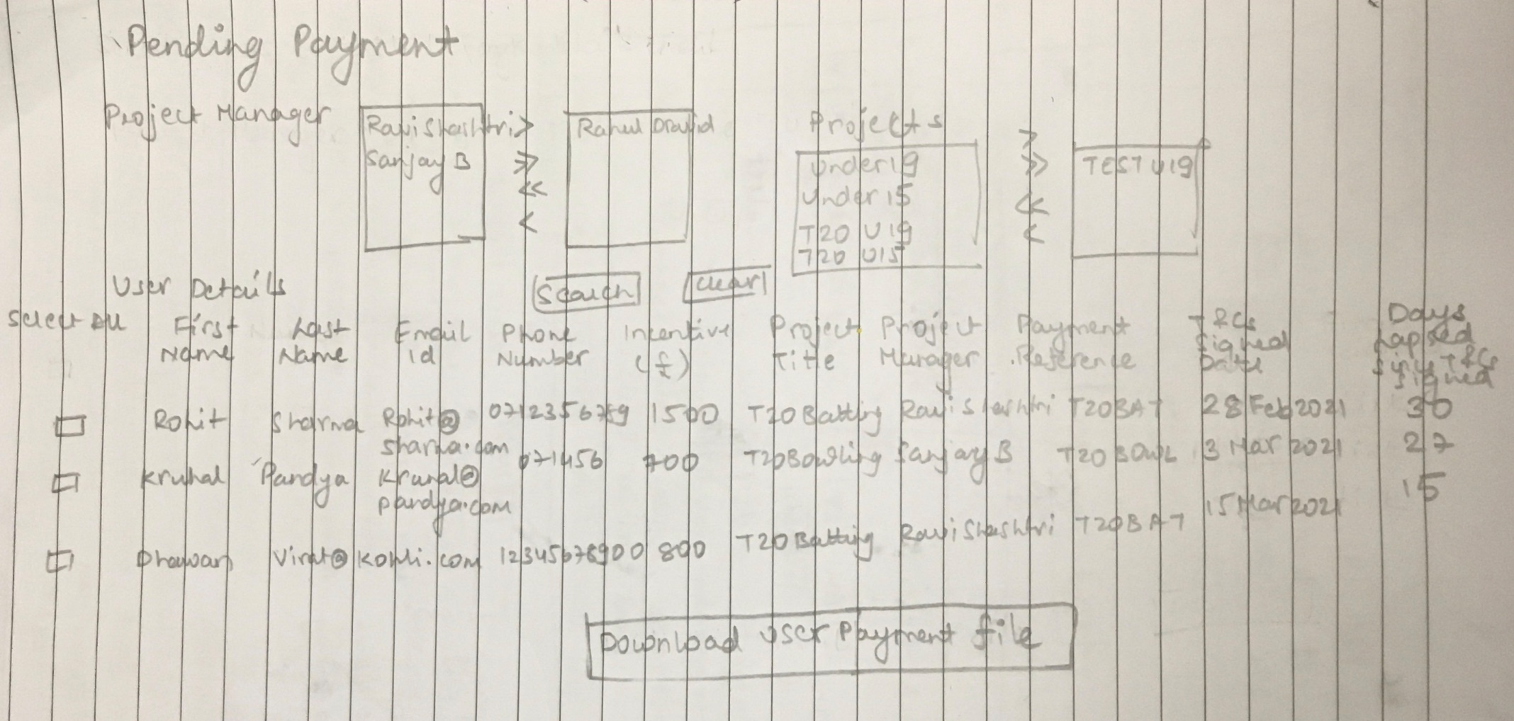

|  |  |  |  |
| --- | --- | --- | --- |
| **Field Name** | **Field Type/Description** | **Validation** | **Comments** |
| Users Pending Bank Details | Screen Title | NA | NA |
| Company | Multiple selectable field | Display all the companies  By Default – All  It should be possible to select one project manager or all and  deselect one project manager or all | This field is displayed only to the ProejctWize admin |
| Project Manager | Multiple selectable field | Display all the project managers that are mapped to the company.  By Default – All | It should be possible to select one project manager or all and  deselect one project manager or all |
| Project Title | Multiple selectable field | Display all the projects that are mapped to the selected project managers.  By Default – All | It should be possible to select one project manager or all and  deselect one project manager or all |
| Search | Button | Display users for the selected projects or selected project managers that are mapped to the company.  By Default – All |  |
| Clear | Button | Clears all selection. No project manager or project selected. |  |
| User Details | Title of the table |  | The users must be sorted on the last email sent date with the oldest record (date) first/top of the list |
|  |  |  |  |
| First Name | Label | Display the First Name of the user from the uploaded file or manually added user |  |
| Last Name | Label | Display the Last Name of the user from the uploaded file or manually added user |  |
| Email Id | Label | Display the Email id of the user from the uploaded file or manually added user |  |
| Phone Number | Label | Display the Phone number of the user from the uploaded file or manually added user |  |
| Incentive | Label | Display the Incentive of the user from the uploaded file or manually added user |  |
| Project Title | Label | Display the Project Title of the user from the uploaded file or manually added user |  |
| Project Manager | Label | Display the Project Title of the user from the uploaded file or manually added user |  |
| Payment Reference | Label | Display the Payment Reference of the user from the project details |  |
| T&Cs signed date | Label | The date on which the T&CS were signed | This field is displayed only to the ProjectWize admin |
| Days lapsed since T&Cs signed | Label | Days passed since the T&CS were signed (T&CS signed date– Today’s date) | This field is displayed only to the ProjectWize admin |
| Download users | Button | Downloads the displayed user |  |

**PAID**

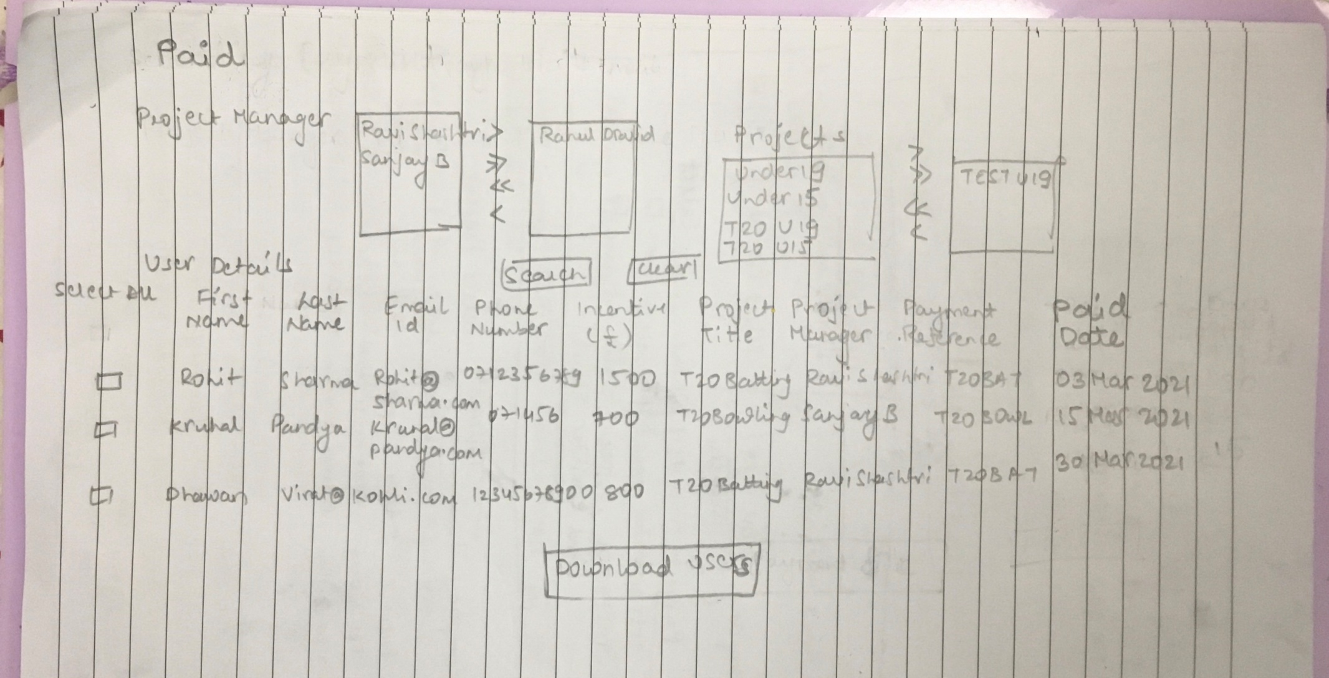

|  |  |  |  |
| --- | --- | --- | --- |
| **Field Name** | **Field Type/Description** | **Validation** | **Comments** |
| Users Pending Bank Details | Screen Title | NA | NA |
| Company | Multiple selectable field | Display all the companies  By Default – All  It should be possible to select one project manager or all and  deselect one project manager or all | This field is displayed only to the ProejctWize admin |
| Project Manager | Multiple selectable field | Display all the project managers that are mapped to the company.  By Default – All | It should be possible to select one project manager or all and  deselect one project manager or all |
| Project Title | Multiple selectable field | Display all the projects that are mapped to the selected project managers.  By Default – All | It should be possible to select one project manager or all and  deselect one project manager or all |
| Search | Button | Display users for the selected projects or selected project managers that are mapped to the company.  By Default – All |  |
| Clear | Button | Clears all selection. No project manager or project selected. |  |
| User Details | Title of the table |  | The users must be sorted on the last email sent date with the oldest record (date) first/top of the list |
| Download users | Button | Downloads the displayed user |  |
| First Name | Label | Display the First Name of the user from the uploaded file or manually added user |  |
| Last Name | Label | Display the Last Name of the user from the uploaded file or manually added user |  |
| Email Id | Label | Display the Email id of the user from the uploaded file or manually added user |  |
| Phone Number | Label | Display the Phone number of the user from the uploaded file or manually added user |  |
| Incentive | Label | Display the Incentive of the user from the uploaded file or manually added user |  |
| Project Title | Label | Display the Project Title of the user from the uploaded file or manually added user |  |
| Project Manager | Label | Display the Project Title of the user from the uploaded file or manually added user |  |
| Payment Reference | Link | Display the Payment Reference of the user from the project details  When clicked on the link displays the payment/transaction details |  |
| Paid date | Label | The date on which the user was paid |  |
| Download users | Button | Downloads the displayed user |  |

**Payment/Transaction details**

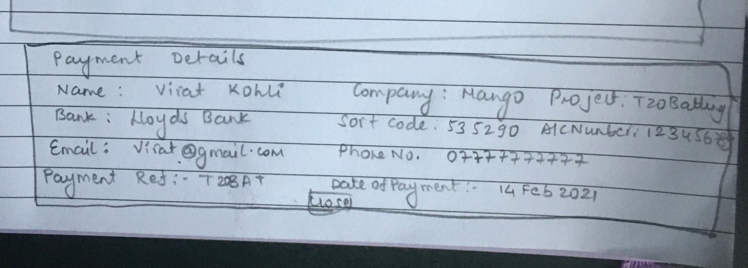

|  |  |  |  |
| --- | --- | --- | --- |
| **Field Name** | **Field Type/Description** | **Validation** | **Comments** |
| Payment Details | Title of the table |  |  |
| Name | Label | Display the First Name & Last name of the user from the uploaded file or manually added user |  |
| Company | Label | Display the name of the company |  |
| Project Title | Label | Display the Project Title of the user from the uploaded file or manually added user |  |
| Bank name | Label | Name of the bank to which payment was made |  |
| Sort code | Label | Sort code to which payment was made |  |
| Account number | Label | Account no. to which payment was made |  |
| Email Id | Label | Display the Email id of the user from the uploaded file or manually added user |  |
| Phone Number | Label | Display the Phone number of the user from the uploaded file or manually added user |  |
| Incentive amount | Label | Display the Incentive of the user from the uploaded file or manually added user |  |
| Payment Reference | Label | Display the Payment Reference of the user from the project details  When clicked on the link displays the payment/transaction details |  |
| Paid date | Label | The date on which the user was paid |  |
| Close | Button | Closes the pop-window |  |

**Manually add user**

The company admin first need to add

* Project manager & Project details
* Add user details manually

The project manager will also have the capability to add

* Project details
* Add user details manually

**Email Templates**

**Standard Templates:**

These will be different types of standard email templates

1. Provide Bank Details
2. 1st reminder – Pending bank details
3. 2nd reminder – Pending bank details
4. 1st reminder – Pending T&Cs
5. 2nd reminder – Pending T&Cs
6. Provide Bank Details

Subject: Bank details for payment of research project <Project Title>

Dear <Salutation><First name><Last name>

Many thanks for taking part in our research about <Project Title>.

You are now eligible for a payment of £<incentive>. To pay you the incentive amount we need your bank details. Kindly click on the link below to provide your bank details.

Enter bank details (link)

Sincerely,

<Project Manager of the project>

<Project Manager Contact no.>

1. 1st reminder – Pending bank details

Subject: Gentle Reminder – Pending bank details for research project <Project Title>

Dear <Salutation><First name><Last name>

Many thanks for taking part in our research about <Project Title>.

You are now eligible for a payment of £<incentive>. To pay you the incentive amount we need your bank details. Kindly click on the link below to provide your bank details.

This is a gentle reminder to provide your bank details.

Enter bank details (link)

Sincerely,

<Project Manager of the project>

<Project Manager Contact no.>

1. 2nd reminder – Pending bank details

Subject: 2nd Reminder – Pending bank details for research project <Project Title>

Dear <Salutation><First name><Last name>

Many thanks for taking part in our research about <Project Title>.

You are now eligible for a payment of £<incentive>. To pay you the incentive amount we need your bank details. Kindly click on the link below to provide your bank details.

This is a gentle reminder to provide your bank details, without which we are unable to process your payment.

Enter bank details (link)

Sincerely,

<Project Manager of the project>

<Project Manager Contact no.>

1. 1st reminder – Pending T&Cs

Subject: Pending T&Cs signature for research project <Project Title>

Dear <Salutation><First name><Last name>

Many thanks for taking part in our research about <Project Title> and providing your bank details.

To enable us to pay you the incentive amount we need you need to digitally sign the project terms & conditions.

Kindly click on the link below to digitally sign the project terms & conditions.

Sign T&Cs now (link)

Sincerely,

<Project Manager of the project>

<Project Manager Contact no.>

1. 2nd reminder – Pending T&Cs

Subject: Reminder Pending T&Cs signature for research project <Project Title>

Dear <Salutation><First name><Last name>

Many thanks for taking part in our research about <Project Title> and providing your bank details.

To enable us to pay you the incentive amount we need you need to digitally sign the project terms & conditions.

This is a gentle reminder to digitally sign the terms & conditions.

Kindly click on the link below to digitally sign the project terms & conditions.

Sign T&Cs now (link)

Sincerely,

<Project Manager of the project>

<Project Manager Contact no.>

**Customise Email Templates:**

These will be different types of standard email templates

1. Provide Bank Details

Provide Bank Details template

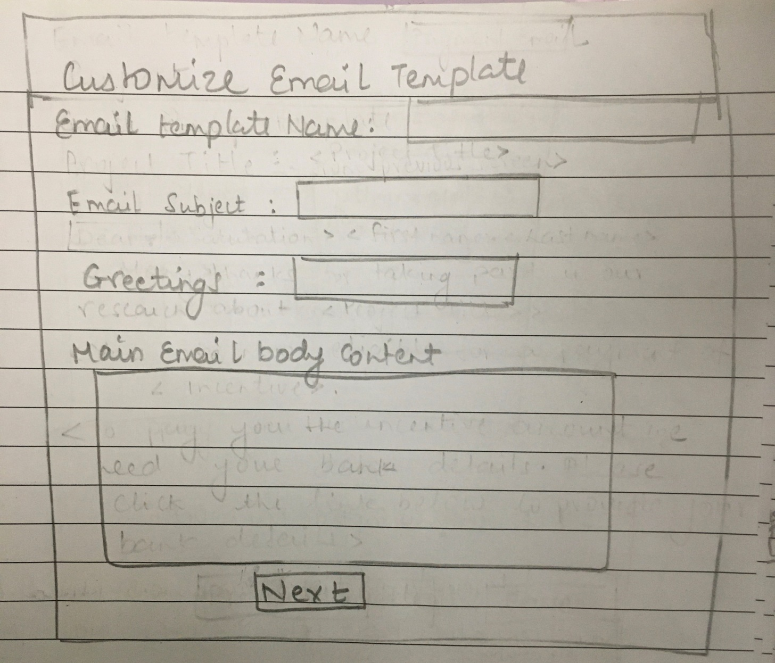

|  |  |  |  |
| --- | --- | --- | --- |
| **Field Name** | **Field Type/Description** | **Validation** | **Comments** |
| Email Template Name | Text Box | Mandatory, Alphanumeric  Minimum 5 characters  Max 50 |  |
| Subject: | Text Box | Mandatory, Alphanumeric  Minimum 20 characters  Max 250 |  |
| Greetings | Text Box | Optional  Cannot be 1 character, Minimum 2 characters  Max 20 | e.g. Dear, Hello, Greetings from Cricket Ltd |
| <Salutation><First name><Last name> | Label | User’s Salutation, first name, last name |  |
| <Main email body content> | Text Field | Mandatory  Mandatory, Alphanumeric  Minimum 100 characters  Max 500 |  |
| Ending greetings | Text Box | Optional  Cannot be 1 character, Minimum 2 characters  Max 20 |  |
| <Project Manager of the project> | Label | Name of the project manager |  |
| <Project Manager Contact no.> | Label | Contact number of the project manager |  |
| Next | Button | Displays the entered details in an email format in the next screen/window |  |
|  |  |  |  |

**Confirm Email template**

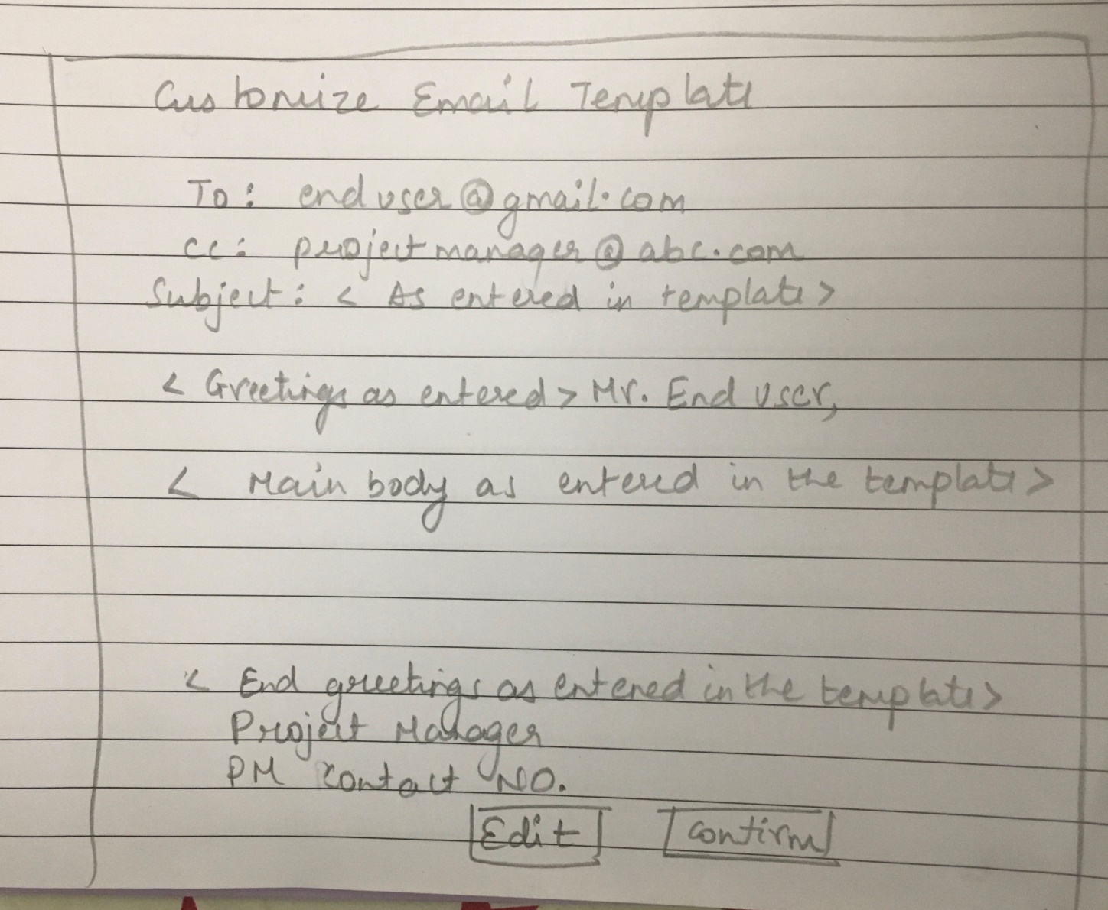

|  |  |  |  |
| --- | --- | --- | --- |
| **Field Name** | **Field Type/Description** | **Validation** | **Comments** |
| Email Template Name | Label | As entered by user in the email template |  |
| To | Label | [enduser@gmail.com](mailto:enduser@gmail.com) |  |
| Cc | Label | Project [manager@abc.com](mailto:manager@abc.com) |  |
| Subject: | Label | As entered by user in the email template |  |
| Greetings | Text Box | As entered by user in the email template |  |
| <Salutation><First name><Last name> | Label | Mr. End User |  |
| <Main email body content> | Label | As entered by user in the email template |  |
| Ending greetings | Label | As entered by user in the email template |  |
| <Project Manager of the project> | Label | Project Manager |  |
| <Project Manager Contact no.> | Label | Project Manager Contact number |  |
| Edit | Button | Takes user back to the customise email template screen |  |
| Confirm | Button | Saves the email template and displays the success screen |  |

**Email template saved success screen**

